**TITLE OF THE PROJECT**

## A PROJECT REPORT

***Submitted by,***

**Ms. Vaishnavi C - 20211CSE0846**

**Ms. Shruthi V-20211CSE0298**

**Ms. Ruthika S Shetty - 20211CSE0308**

### *Under the guidance of,*

**Ms. Sreelatha P.K**

***in partial fulfillment for the award of the degree of***

**BACHELOR OF TECHNOLOGY**

**IN**

**COMPUTER SCIENCE AND ENGINEERING, COMPUTER ENGINEERING, INFORMATION SCIENCE AND ENGINEERING Etc.**

**At**



**PRESIDENCY UNIVERSITY**

**BENGALURU**

**DECEMBER 2024**

**PRESIDENCY UNIVERSITY**

**SCHOOL OF COMPUTER SCIENCE ENGINEERING**

**CERTIFICATE**

This is to certify that the Project report **“Tourism Data Exploration: Analysis and Visualization for Impactful Insights”** being submitted by “VAISHNAVI C, SHRUTHI V AND RUTHIKA S SHETTY” bearing roll number(s) “20211CSE0846, 20211CSE0298 AND 20211CSE0308” in partial fulfillment of the requirement for the award of the degree of Bachelor of Technology in Computer Science and Engineering is a bonafide work carried out under my supervision.

|  |  |
| --- | --- |
| **Ms. Sreelatha P.K**  Assistant Professor  School of CSE&IS  Presidency University | **Dr. Asif Mohammed H.B**  HoD  School of CSE&IS  Presidency University |

|  |  |  |
| --- | --- | --- |
| **Dr. L. SHAKKEERA**  Associate Dean  School of CSE  Presidency University | **Dr. MYDHILI NAIR**  Associate Dean  School of CSE  Presidency University | **Dr. SAMEERUDDIN KHAN**  Pro-VC School of Engineering  Dean -School of CSE&IS  Presidency University |

**PRESIDENCY UNIVERSITY**

**SCHOOL OF COMPUTER SCIENCE ENGINEERING**

**DECLARATION**

We hereby declare that the work, which is being presented in the project report entitled **Tourism Data Exploration: Analysis and Visualization for Impactful Insights** in partial fulfillment for the award of Degree of **Bachelor of Technology** in **Computer Science and Engineering**, is a record of our own investigations carried under the guidance of **Ms. Sreelatha P.K, Assistant Professor,** **School of Computer Science Engineering & Information Science, Presidency University, Bengaluru.**

We have not submitted the matter presented in this report anywhere for the award of any other Degree.

**Vaishnavi C (20211CSE0846)**

|  |  |
| --- | --- |
|  | **Shruthi V (20211CSE0298)**    **Ruthika S Shetty (20211CSE0308)** |

**ABSTRACT**

**1.1 Overview**

Tourism is a vital industry, contributing significantly to global GDP and fostering cultural exchange. India, with its rich cultural and geographic diversity, attracts millions of travellers annually. However, evolving traveller preferences and increasing data availability demand advanced analytical approaches for better tourism management. Traditional methods of managing tourism lack the precision and scalability offered by modern data-driven techniques.

This project leverages Artificial Intelligence (AI) and Machine Learning (ML) to analyse tourist data. Using clustering and predictive modelling, the study identifies trends, segments destinations, and provides actionable insights for improved tourism planning. By employing algorithms such as K-Means for clustering and Random Forest for predictive modelling, the project aims to revolutionize tourism management by offering sustainable, personalized, and efficient solutions.

**1.1.1 Significance of Tourism Analytics**

Tourism analytics helps stakeholders make data-driven decisions to optimize resources, improve traveller experiences, and promote sustainability. Key benefits include:

- **Resource Optimization**: Grouping destinations based on shared characteristics to manage resources effectively.

- **Personalized Travel Experiences**: Predicting traveller preferences for designing customized tour packages.

- **Marketing Strategies**: Targeting specific demographics through insights from tourism data.

- **Sustainability**: Promoting balanced tourism to prevent over-tourism and conserve resources.

**1.2 Motivation**

The project is driven by the need to address challenges in the tourism sector, such as seasonality, resource mismanagement, and lack of personalized services. The primary motivations include:

1. **Enhancing Data Utilization**: Addressing the gap in using existing data to extract actionable insights.

2. **Improving Traveller Experiences**: Understanding tourist preferences for tailored services.

3. **Supporting Sustainability**: Developing data-driven solutions to promote eco-friendly practices.

4. **Fostering Regional Development**: Identifying underexplored regions with high tourism potential.

This project aims to use AI/ML techniques to unlock the full potential of tourism analytics, fostering economic growth and sustainable practices.

**1.3 Scope of the Project**

The project focuses on utilizing a dataset of Indian tourist destinations to explore patterns and predict trends. The major areas covered include:

1. **Data Pre-processing**: Cleaning and transforming data for analysis.

2. **Clustering Analysis**: Using K-Means to group destinations based on similarities.

3. **Predictive Modelling**: Employing Random Forest to predict destination significance.

4. **Actionable Recommendations**: Providing insights to stakeholders for resource planning and marketing strategies.

5. **Visualization**: Presenting clear visualizations of results using tools like PCA and heatmaps.  
This study demonstrates how AI/ML can address real-world challenges in tourism, offering scalable and sustainable solutions for the industry.

**ACKNOWLEDGEMENT**

First of all, we indebted to the **GOD ALMIGHTY** for giving me an opportunity to excel in our efforts to complete this project on time.

We express our sincere thanks to our respected dean **Dr. Md. Sameeruddin Khan**, Pro-VC, School of Engineering and Dean, School of Computer Science Engineering & Information Science, Presidency University for getting us permission to undergo the project.

We express our heartfelt gratitude to our beloved Associate Deans **Dr. Shakkeera L and Dr. Mydhili Nair,** School of Computer Science Engineering & Information Science, Presidency University, and Dr. “Asif Mohammed H.B”, Head of the Department, School of Computer Science Engineering & Information Science, Presidency University, for rendering timely help in completing this project successfully.

We are greatly indebted to our guide **Ms. Sreelatha P.K, Assistant Professor** and Reviewer **Ms. Megha D, Assistant Professor** School of Computer Science Engineering & Information Science, Presidency University for her inspirational guidance, and valuable suggestions and for providing us a chance to express our technical capabilities in every respect for the completion of the project work.

We would like to convey our gratitude and heartfelt thanks to the PIP2001 Capstone Project Coordinators **Dr. Sampath A K, Dr. Abdul Khadar A and Mr. Md Zia Ur Rahman,** department Project Coordinators “**Mr. Amarnath J.L & Dr. Jayanthi. K**” and Git hub coordinator **Mr. Muthuraj.**

We thank our family and friends for the strong support and inspiration they have provided us in bringing out this project.

**Vaishnavi C**

**Shruthi V**

**Ruthika S Shetty**

**LIST OF TABLES**

|  |  |  |  |
| --- | --- | --- | --- |
| **Sl. No.** | **Table Name** | **Table Caption** | **Page No.** |
| 1 | Table 1.1 | Software modules versus Reusable components | 5 |

**LIST OF FIGURES**

|  |  |  |  |
| --- | --- | --- | --- |
| **Sl. No.** | **Figure Name** | **Caption** | **Page No.** |
| 1 | Figure 1.1 | Software modules versus Reusable components | 5 |

**TABLE OF CONTENTS**

|  |  |  |
| --- | --- | --- |
| **CHAPTER NO.** | **TITLE** | **PAGE NO.** |
|  | **ABSTRACT ACKNOWLEDGMENT**  **…** | **i**  **ii**  **…** |
| **1.** | **INTRODUCTION** | 1 |
|  | 1.1 GENERAL | 1 |
|  | 1.2 . . . . . . . . . . . . | 2 |
|  | 1.2.1 General | 5 |
|  | 1.2.2.1 General | 8 |
|  | 1.2.2.2 . . . . . . . . | 10 |
|  | 1.2.2 | 12 |
|  | 1.3 . . .. . . . . . .. . . . . . . | 13 |
|  | 1.4 . . . . . . . . . . . . . . . . | 15 |
| **2.** | **LITERATURE REVIEW** | **16** |
|  | 2.1 GENERAL | 17 |
|  | 2.2 . . . . .. | 19 |
|  | 2.2. | 20 |

**CHAPTER-1**

**INTRODUCTION**

#### **1.1 Overview**

Tourism is a vital industry, contributing significantly to global GDP and fostering cultural exchange. India, with its rich cultural and geographic diversity, attracts millions of travellers annually. However, evolving traveller preferences and increasing data availability demand advanced analytical approaches for better tourism management. Traditional methods of managing tourism lack the precision and scalability offered by modern data-driven techniques.

This project leverages Artificial Intelligence (AI) and Machine Learning (ML) to analyse tourist data. Using clustering and predictive modelling, the study identifies trends, segments destinations, and provides actionable insights for improved tourism planning. By employing algorithms such as K-Means for clustering and Random Forest for predictive modelling, the project aims to revolutionize tourism management by offering sustainable, personalized, and efficient solutions.

##### **1.1.1 Significance of Tourism Analytics**

Tourism analytics helps stakeholders make data-driven decisions to optimize resources, improve traveller experiences, and promote sustainability. Key benefits include:

* **Resource Optimization**: Grouping destinations based on shared characteristics to manage resources effectively.
* **Personalized Travel Experiences**: Predicting traveler preferences for designing customized tour packages.
* **Marketing Strategies**: Targeting specific demographics through insights from tourism data.
* **Sustainability**: Promoting balanced tourism to prevent over-tourism and conserve resources.

By analysing patterns in the data, this project provides actionable recommendations for tourism boards and travel agencies.

#### **1.2 Motivation**

The project is driven by the need to address challenges in the tourism sector, such as seasonality, resource mismanagement, and lack of personalized services. The primary motivations include:

1. **Enhancing Data Utilization**: Addressing the gap in using existing data to extract actionable insights.
2. **Improving Traveler Experiences**: Understanding tourist preferences for tailored services.
3. **Supporting Sustainability**: Developing data-driven solutions to promote eco-friendly practices.
4. **Fostering Regional Development**: Identifying underexplored regions with high tourism potential.

This project aims to use AI/ML techniques to unlock the full potential of tourism analytics, fostering economic growth and sustainable practices.

#### **1.3 Scope of the Project**

The project focuses on utilizing a dataset of Indian tourist destinations to explore patterns and predict trends. The major areas covered include:

1. **Data Preprocessing**: Cleaning and transforming data for analysis.
2. **Clustering Analysis**: Using K-Means to group destinations based on similarities.
3. **Predictive Modeling**: Employing Random Forest to predict destination significance.
4. **Actionable Recommendations**: Providing insights to stakeholders for resource planning and marketing strategies.
5. **Visualization**: Presenting clear visualizations of results using tools like PCA and heatmaps.

**CHAPTER-2**

**LITERATURE SURVEY**

The study by Jiantao Wu et al explores the impact of climate change on the tourism economy, a topic not yet fully realized despite increasing climate concerns. Using knowledge graph techniques, including weather data, the study aims to deepen understanding of the relationship between climate and tourism. Findings suggest that organizing climate and tourism data through knowledge graphs can provide valuable insights, potentially enhancing both quality of life and the resilience of the tourism industry. Method includes importing CSV datasets into a Neo4j knowledge graph (KG) using CYPHER’s LOAD CSV command. Entities like "Airport" and relationships between "City" and "Weather Station" were mapped, with intermediate CSV files linking "Station" IDs to city names. Key properties, such as geodesic distances, were added to enhance data utility and calculation efficiency within the KG.

The data was collected from various resources like NOAA GHCND, AviationStack, Climateq, Simplemaps **[1]**.

This study by Olimpia Alcaraz et al investigates the intersection of physical and digital realms in tourism, introducing smart tourism destinations (STDs) that leverage technology and open data to enhance visitor experiences and inform decision-making. It demonstrates how integrating open data with local business campaign data can innovate tourism management and foster smart ecosystems through public-private collaboration. An AI-based search engine using word embeddings was developed to identify relevant open data, improving traditional data retrieval. The findings highlight the potential of this integration to enrich tourist experiences and support destination management strategies, contributing insights on combining retail and open data in a real case study.

The initial internal data used in this study are derived from local campaigns known as *bono consumo* (consumer voucher), a promotional campaign resulting from the health crisis caused by COVID-19. The initial private dataset was compiled by APYMECO, the local traders’ association, which gathered data on the usage of consumer vouchers in the four editions of the campaign: October 2021, June 2022, September 2022, and November 2022. This dataset comprises more than 300,000 entries **[2]**.

This paper by Saman Forouzandeh et al introduces a novel approach to travel recommendation systems in the tourism industry, combining the Artificial Bee Colony (ABC) algorithm with Fuzzy TOPSIS. The Techniques for Order of Preference by Similarity to Ideal Solution (TOPSIS) is utilized as a multi-criteria decision-making method to optimize recommendations. Data were collected through an online questionnaire from 1,015 respondents on Facebook. In the first stage, the TOPSIS model identifies a positive ideal solution based on four key factors. In the second stage, the ABC algorithm searches for destinations to recommend the best tourist spot to users, enhancing the decision-making process for tourists.

The data was gathered through questionnaires provided to self-driven travelers. The authors distributed a survey to hotel visitors to gather data on the level of service. The data gathered by questionnaires, the exploration of popular topics, and the difficulty of materials were valued **[3]**.

This paper by Tao Peng et al aims to enhance tourism demand forecasting accuracy by integrating social network data with traditional data sources. Using a web crawler, the authors collect social network data and apply sentiment analysis using the BERT model. The study builds a forecasting model based on Gradient Boosting Regression Trees, incorporating structured variables such as weather and holidays. Using Huang Shan as a case study, the authors conduct an empirical analysis comparing the model's performance against existing models, supported by an ablation study. Results indicate that incorporating social network data significantly improves forecasting accuracy for tourism demand.

Social network data acquisition is mainly achieved through web crawlers, which can collect and organize data on the Internet in accordance with established rules **[4]**.

This study by İbrahim Topal and Muhammed Kürşad Uçar explores the growing importance of the tourism and travel sector in the global economy, emphasizing the influence of social media on consumer purchasing decisions. By analyzing historical user data from TripAdvisor, the research aims to employ artificial intelligence methods to identify profiles of consumers likely to prefer Turkey as a travel destination. This approach enables businesses to target the right audience and enhance the effectiveness of their promotional activities. Methods like F-Score Feature Selection Algorithm, classifiers such as Decision trees (DT), k Nearest Neighbors Classification Algorithm (KNN), Multilayer Feedforward Artificial Neural Networks (MLFFNN), Probabilistic Neural Networks (PNN), and Support Vector Machines (SVMs) were used.

The study used the travel data history of Chinese tourists taken from TripAdvisor. The data belong to a total of 624 users. The acquisition of historical data took place between 27 April and 11 May 2018 **[5].**

Nesreen K. Ahmed et al used models like MLP **(**Multilayer Perceptron) for classification/regression, RBF (Radial Basis Function) with Gaussian functions, GRNN (Generalized Regression Neural Network) using a Gaussian kernel, KNN (K-Nearest Neighbors) based on nearest neighbors, CART (Classification and Regression Trees) with decision trees, SVR (Support Vector Regression) using support vectors, and GP **(**Gaussian Processes**)** modeling data as a Gaussian process. This study explores machine learning methods for tourism demand forecasting, traditionally dominated by models like ARIMA and exponential smoothing. It evaluates the performance of seven machine learning models on Hong Kong’s inbound travel data and examines the impact of adding the time index as an input variable, comparing these models' effectiveness against conventional approaches.

In this study, data published in the study made by Law and Pine to forecast inbound travel demand for Hong Kong was used **[6]**.

The study by Ram Krishn Mishra et al shows the use of SVR and Random Forest Regressor. SVR (Support Vector Regression), adapted from Support Vector Machines, is used for predicting real-number data, offering infinite possible solutions for continuous outputs. Random Forest Regressor is a tree-based model that splits data into nodes, with predictions made by averaging responses in terminal nodes for regression tasks. It improves prediction accuracy and reduces overfitting by constructing multiple decision trees on different sub-samples of the dataset, making it more robust than a single decision tree, which is prone to overfitting due to random noise. This study examines international tourist data from 2010 to 2020, analyzing multiple dimensions to identify valuable features for forecasting. Using Support Vector Regression (SVR) and Random Forest Regression (RFR), the research predicts global tourist arrivals, achieving forecasting accuracies of 99.4% and 84.7%, respectively. The study also addresses the impact of COVID-19 lockdowns on forecasting accuracy.

A substantial amount of data gathered by the government or other public entities is made available. These data sets are referred to as public data since they do not require specific authorization to use them **[7]**.

The study by Noelyn M. De Jesus et al used time series data of tourist arrivals, particularly around the COVID-19 pandemic, splitting the dataset into three partitions for model training and testing. These partitions were based on key events like the first COVID-19 case (January 2020), travel suspensions (March 2020), and stricter entry restrictions (December 2020). The dataset was loaded into the Orange Data Mining tool, and a Multilayer Perceptron (MLP) neural network was used for time series prediction. The model’s performance was evaluated using metrics like MSE, RMSE, MAE, MAPE, and R². The best model was selected based on the highest R² and lowest MAPE, indicating how well the predictions matched the actual values. This research evaluates the predictive power of an artificial neural network (ANN) model for forecasting tourist arrivals, using tourism data from the Philippines spanning 2008-2022. The ANN was trained on three distinct data compositions and assessed with various time series evaluation metrics, achieving an R-squared value of 0.926 and a MAPE of 13.9%. The study found that including data from unexpected events, like the COVID-19 pandemic, improved model accuracy. The findings suggest that ANN can be a valuable tool for government and tourism stakeholders to support strategic and investment decisions.

The researchers collected the actual inbound tourist arrivals to Philippines between 2008-2022 from the Department of Tourism’s official website **[8]**.

This article reviews machine learning techniques for predicting tourism, specifically analyzing prior studies in this domain. Bilal Sultan Abdualgalil et al discuss various machine learning techniques applied to tourism data analysis, focusing on two primary activities: association learning and classification learning. Key techniques include **Logistic Regression** and **Linear Regression** for predicting binary and continuous outcomes, respectively; **Decision Trees** and **Random Forests** for supervised classification and regression; **Support Vector Machines** for binary classification; and **Naive Bayes** for fast and effective classification. Additionally, **KNN** is highlighted for its simplicity in classifying data based on nearest neighbors, while **K-Means Clustering** is used for unsupervised grouping of data. Other methods like **Dimensionality Reduction** (e.g., PCA) simplify datasets, and **Gradient Boosting** and **AdaBoost** improve model accuracy through iterative refinement. The results showed higher prediction accuracy when using the first-quarter dataset, demonstrating its effectiveness for forecasting tourist numbers.

The dataset obtained from www.kaggel.com website was used **[9]**.

This study by **Dinda Thalia Andariesta et al** presents machine learning models for predicting international tourist arrivals in Indonesia during the COVID-19 pandemic using multisource Internet data. In this study, data from the Indonesian Statistical Bureau, TripAdvisor, and Google Trends were used to develop prediction models for international tourist arrivals. The process involved data preprocessing, feature extraction, and forecasting model development using ANN, SVR, and Random Forest. These models were evaluated using RMSE, MAE, and MAPE to ensure accuracy. The ANN model used previous tourist data, online posts, and search volumes as predictors. The RF model, known for its reliability, averaged predictions from multiple decision trees to improve forecasting performance.

First, the researchers collected tourism data from the Indonesian Statistical Bureau Indonesia or BPS from January 2017 until June 2021. Next, we collect the data from a global online tourism platform, TripAdvisor **[10]**.

**CHAPTER-3**

**RESEARCH GAPS OF EXISTING METHODS**

1. **Scalability and Data Integration Challenges**

Many studies encounter scalability issues, particularly when integrating multi-source data. For example, integrating diverse climate and tourism datasets to build knowledge graphs faces challenges as more data sources are added, limiting the model's efficiency in handling large-scale applications. Additionally, augmenting retail data with open datasets encounters compatibility issues, as open data is not always readily available or uniformly structured, further complicating integration efforts.

1. **Limitations in Real-Time Application**

Several existing methods rely heavily on historical data, which limits their applicability in real-time scenarios. For instance, models focusing on climate data and tourism relationships fail to address real-time decision-making needs due to their dependence on past datasets. Similarly, high computational demands in hybrid recommendation systems and AI-based forecasting approaches hinder their ability to deliver quick and actionable insights in real-time.

1. **Privacy and Data Access Issues**

The utilization of consumer and open data raises significant privacy concerns. Studies leveraging retail and open data for smarter tourism often face ethical and regulatory challenges, making it difficult to use consumer data without breaching privacy norms. Furthermore, accessing and pre-processing such data can be time-intensive and may not always yield consistent results.

1. **High Computational Requirements**

Many state-of-the-art methods require extensive computational resources, which may not be feasible for widespread adoption. For example, hybrid models that use evolutionary algorithms, TOPSIS, or artificial neural networks (ANNs) demand significant computational power, especially for processing and analysing complex data patterns. This limitation is particularly pronounced in real-time or resource-constrained environments.

1. **Dependence on Specific Data Sources**

Several models are overly reliant on specific platforms or types of data. For example, methods predicting tourist preferences for Chinese tourists depend heavily on TripAdvisor data, limiting the generalizability of insights across diverse tourist populations. Similarly, models leveraging social media data or Google Trends are vulnerable to biases inherent in these platforms, which may not always reflect actual demand or tourist behaviour.

1. **Scalability and Adaptability Challenges**

Existing tourism systems struggle to scale during periods of high demand, such as peak travel seasons or major events, leading to server crashes, delays in processing, and reduced functionality. Additionally, they lack adaptability to integrate emerging technologies like augmented reality (AR) or virtual reality (VR) to enrich the tourism experience. These systems also fail to incorporate data from new sources, such as social media trends or real-time environmental changes, making them less responsive to tourists' evolving needs.

1. **Limited Data Interoperability and Analytics**

Tourism data is often dispersed across multiple entities—hotels, airlines, local businesses, and government agencies—with little to no interoperability between them. This results in missed opportunities for leveraging big data to generate actionable insights. For instance, platforms could use predictive analytics to anticipate peak travel periods, optimize pricing strategies, or recommend alternative destinations. However, the absence of unified data standards prevents stakeholders from collaborating effectively to enhance the tourist experience.

1. **Environmental and Sustainability Concerns**

Modern tourism systems seldom prioritize sustainability. There is limited integration of environmental monitoring or eco-friendly practices into tourism solutions. Platforms rarely provide tourists with real-time updates on environmental conditions, carbon footprints of their travel choices, or recommendations for sustainable alternatives. This gap prevents the tourism industry from aligning with global sustainability goals and addressing climate change impacts.

1. **Inadequate Support for Multilingual and Diverse Cultural Needs**

Many existing platforms offer limited support for multilingual users or fail to cater to diverse cultural needs. For international travellers, language barriers remain a significant challenge when navigating foreign destinations. Similarly, recommendations often fail to consider cultural preferences, dietary restrictions, or local customs, leading to suboptimal experiences for tourists from different backgrounds.

1. **Weak Crisis Management Capabilities**

Current tourism platforms are ill-equipped to handle unexpected disruptions, such as natural disasters, pandemics, or political instability. There is a lack of integrated crisis management features, such as automated alerts, alternative plans, or rapid resource reallocation. This makes it difficult for tourists to adapt to sudden changes or for service providers to mitigate the impact of crises on their operations.

**CHAPTER-4**

**PROPOSED METHODOLOGY**

#### 1. **Data Collection**

Data collection is the foundational step of the process, focusing on gathering diverse and comprehensive datasets.

* **Sources of Data**: Data is sourced from social media platforms (e.g., Twitter, Instagram, and Facebook), travel review platforms (e.g., TripAdvisor, Google Reviews), and user interaction logs from tourism-related websites or apps. Social media data provides insights into public sentiment, trending destinations, and real-time updates on tourist behavior. Travel platforms contribute structured reviews, ratings, and destination-specific information, while user interaction data captures personalized preferences, search patterns, and booking behaviors.
* **Purpose**: Collecting data from multiple sources ensures diversity, enabling a holistic analysis of tourism trends and preferences. It also allows the model to capture dynamic factors such as seasonal shifts, sudden changes in demand, or emerging trends in the tourism sector.

#### 2. **Data Pre-Processing**

#### The raw data collected is often incomplete, noisy, or inconsistent, necessitating pre-processing before it can be used for analysis.

* **Data Cleaning**: This step removes inconsistencies such as duplicate records, missing values, and irrelevant data. For example, irrelevant social media posts or incomplete reviews are filtered out to maintain dataset quality.
* **Normalization**: Data is standardized to ensure uniformity. For instance, varying formats for dates, currencies, or location names are normalized to ensure compatibility across all datasets.
* **Feature Extraction**: Relevant features are identified and extracted for analysis. Key features may include traveler demographics (age, nationality), destination attributes (location, cost, activities), and sentiment scores from text data. Advanced techniques, such as natural language processing (NLP), are used to extract sentiments, keywords, and topics from unstructured text data like reviews and comments.
* **Purpose**: Effective data pre-processing reduces noise and ensures that the models receive clean, structured data for better performance and accuracy.

#### 3. **Machine Learning**

* **Recommendation Models**: Using collaborative filtering, content-based filtering, or hybrid methods, these models offer personalized suggestions to users. For example, based on a user's past searches and preferences, the system can recommend destinations, accommodations, or activities tailored to their interests.
* **Predictive Models**: These models use historical data and patterns to forecast future trends. For instance, regression models or time series analysis can predict peak tourist seasons, the demand for specific destinations, or the impact of external factors like weather or global events.
* **Clustering Models**: Clustering algorithms such as K-Means or DBSCAN group tourists or destinations based on shared attributes. For example, tourists can be segmented into clusters based on travel preferences, budget ranges, or preferred activities, enabling targeted marketing and customized packages.
* **Purpose**: Machine learning enables the system to derive actionable insights from data, offering accurate and user-focused analytics for both tourists and industry stakeholders.

#### 4. **Visualization**

* **Dashboards**: Interactive dashboards are created using tools like Tableau, Power BI, or Python libraries (e.g., Plotly, Dash, Matplotlib). These dashboards display key metrics, trends, and predictions in an accessible format. For example, users can explore charts showing top destinations, maps of tourist flows, or graphs of seasonal demand fluctuations.
* **Features**: Dashboards may include filtering options to allow users to explore data by region, time period, or demographic group. Real-time data updates and drill-down capabilities provide deeper insights for stakeholders.
* **Purpose**: Visualization bridges the gap between technical analysis and practical decision-making, enabling stakeholders to identify trends, evaluate performance, and implement data-driven strategies effectively.

**CHAPTER-5**

**OBJECTIVES**

#### 1. **Develop a Robust Clustering Algorithm for Tourist Data Segmentation** Segmentation of tourist data is essential for understanding the diverse needs and preferences of travelers. This objective involves exploring and implementing a variety of clustering algorithms, such as K-Means, hierarchical clustering, and DBSCAN, to categorize tourists into distinct groups based on relevant attributes.

* **Attributes for Segmentation**: Demographics (e.g., age, gender, nationality), travel preferences (e.g., adventure, luxury, budget-friendly), and behavioral patterns (e.g., frequency of travel, spending habits) will serve as key features for clustering.
* **Algorithm Selection**: Each clustering algorithm will be evaluated for its ability to handle large, diverse datasets. For instance, K-Means is ideal for well-defined clusters, hierarchical clustering provides insights into relationships between clusters, and DBSCAN is effective for detecting noise and irregular data points.
* **Outcome**: The clustering process will help tourism stakeholders identify distinct groups of tourists, enabling the design of personalized experiences and targeted marketing strategies.

#### 2. **Construct Predictive Models for Forecasting Tourist Travel Clusters** Accurate forecasting of tourist trends is crucial for proactive decision-making. This step focuses on developing and evaluating predictive models such as time series analysis, regression models, and classification models to predict how tourist clusters evolve over time.

* **Time Series Analysis**: This will be used to understand seasonal and temporal trends, such as peak travel periods and off-season dynamics.
* **Regression Models**: These will identify key factors influencing changes in tourist clusters, such as economic shifts, political events, or natural disasters.
* **Classification Models**: These will help categorize future tourists into pre-defined clusters, ensuring predictive accuracy for tailored service offerings.
* **Outcome**: These predictive models will empower tourism authorities and businesses to anticipate changes, optimize resources, and plan effectively for varying levels of demand.

#### 3. **Analyze and Interpret Results from Clustering and Predictive Models** Once the clustering and predictive models are implemented, a thorough analysis of the results is essential to derive meaningful insights.

* **Cluster Characteristics**: Key attributes and behavioral patterns of each cluster will be identified. For example, one cluster might represent budget travelers who prefer off-season travel, while another could consist of luxury tourists seeking high-end services.
* **Trends and Patterns**: By analyzing predictive results, emerging trends—such as an increasing interest in eco-tourism or shifts in travel preferences post-pandemic—can be identified.
* **Outcome**: This step provides a deeper understanding of tourist behaviors and market dynamics, forming the foundation for strategic planning and innovation in tourism services.

#### **Develop Actionable Recommendations for Tourism Authorities**

#### Using insights derived from clustering and predictive models, actionable recommendations will be provided to tourism authorities to enhance their planning and service delivery.

* **Optimizing Resource Allocation**: Authorities can allocate resources efficiently, such as enhancing infrastructure in popular destinations or preparing for peak seasons.
* **Targeted Marketing Campaigns**: Specific clusters can be targeted with tailored marketing strategies. For instance, promoting cultural festivals to tourists interested in heritage or adventure packages to thrill-seekers.
* **Improving Service Offerings**: Insights can guide the development of new services, such as family-friendly amenities, eco-friendly travel options, or luxury accommodations based on identified demand.
* **Outcome**: These recommendations aim to boost tourist satisfaction, increase revenue, and ensure sustainable tourism growth.

**CHAPTER-6**

**IMPLEMENTATION**

#### **1. Dataset Description**

The project uses a wide range of datasets to analyse tourism patterns and trends in India. These datasets include:

1. **India-Tourism-Statistics-1981-2020-fta_nri_ita**:
   * Historical data on Foreign Tourist Arrivals (FTAs), Non-Resident Indians (NRIs), and Indian Tourist Arrivals (ITAs) from 1981 to 2020.
   * Used for trend analysis and forecasting.
2. **India-Tourism-Statistics-2001-2019-agegroup**:
   * Distribution of tourists by age groups between 2001 and 2019.
   * Helpful for understanding demographic trends in tourism.
3. **India-Tourism-Statistics-2001-2019-quaterly**:
   * Quarterly distribution of tourists from 2001 to 2019.
   * Used to analyze seasonality and peak tourist periods.
4. **India-Tourism-Statistics-2001-2019-worldvsindia**:
   * Comparative data showing international vs. domestic tourism from 2001 to 2019.
5. **India-Tourism-Statistics-2019_region-and-reason**:
   * Region-wise data categorized by reasons for travel (e.g., leisure, business).
   * Used to identify regional tourism trends and purposes.
6. **India-Tourism-Statistics-2021-monuments**:
   * Visitor data for major monuments in India in 2021.
   * Helps assess the popularity of historical sites.
7. **India-Tourism-Statistics-region-2017-2019**:
   * Regional tourist trends from 2017 to 2019.
   * Analyzed to study fluctuations and preferences.
8. **India-Tourism-Statistics-statewise_2019-2020_domestic_foreign**:
   * State-wise statistics for domestic and foreign visitors from 2019 to 2020.
   * Enables comparisons between states and identifies popular destinations.
9. **Top Indian Places to Visit**:
   * Details on tourist attractions, including location, type, significance, ratings, and accessibility.
   * Used for clustering and destination analysis.

#### **2. Preprocessing and Integration**

Each dataset was pre-processed and integrated into the analysis pipeline:

* **Handling Missing Values**: Missing data was addressed using forward fill or mean/median replacement.
* **Encoding Categorical Data**: Textual features such as "Type of Attraction" and "Region" were converted to numeric using LabelEncoder.
* **Feature Scaling**: Numerical columns were standardized using StandardScaler for clustering and predictive modeling.
* **Combining Datasets**: Relevant datasets were merged to enable comprehensive analysis across years, regions, and tourist demographics.

#### **3. Clustering and Predictive Modeling**

1. **Clustering Analysis**:
   * **Algorithm**: K-Means was used to cluster destinations based on features like "Review Ratings" and "Entrance Fees."
   * **Visualization**: Clusters were visualized using PCA-based scatter plots to highlight group similarities.
2. **Predictive Analysis**:
   * **Target**: Classify destinations by "Significance" using Random Forest.
   * **Evaluation**: Model accuracy, precision, recall, and F1-score were calculated to assess performance.
3. **Trend Forecasting**:
   * FTAs and ITAs from 1981-2020 were analyzed to predict future trends and identify recovery patterns post-COVID-19.

#### **4. Visualization and Insights**

* **Quarterly Trends**: Seasonal travel patterns were visualized using pie charts.
* **State/Region Analysis**: Bar charts compared domestic vs. foreign tourist arrivals.
* **Age Group Analysis**: Line plots highlighted changing age demographics of travelers.
* **Cluster Insights**: Scatter plots provided actionable insights for grouping destinations.

**CHAPTER-7**

**TIMELINE FOR EXECUTION OF PROJECT**

**(GANTT CHART)**

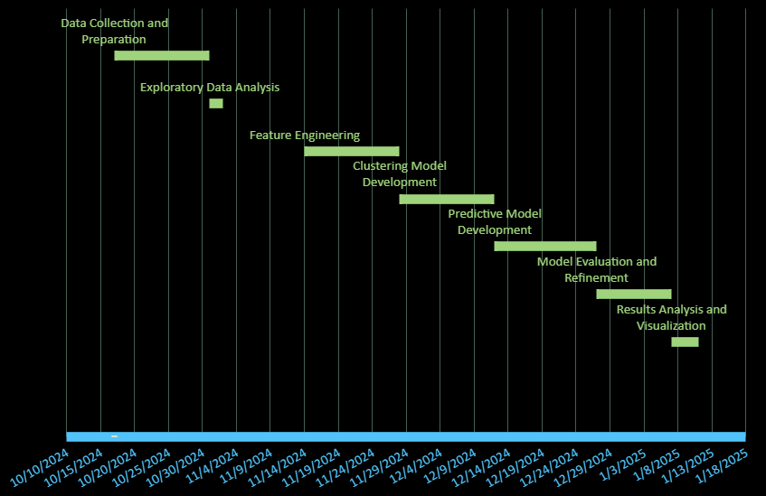

**CHAPTER-8**

**OUTCOMES**

**1. Accurate Tourist Segmentation:** ​

* The clustering model is expected to segment tourists based on demographics, preferences, and behaviors effectively. This will allow tourism authorities and companies to better understand different tourist groups and cater to their needs. ​

**2. Improved Forecasting of Tourist Travel Patterns:** ​

* Predictive models developed will help forecast future tourist behaviors and travel preferences, enabling tourism operators to plan more efficiently and anticipate the needs of tourists in real-time.

**3. Optimized Tour Package Scheduling:** ​

* By forecasting tourist travel clusters, the project aims to optimize the scheduling and customization of domestic tour packages, increasing efficiency in resource allocation and improving tourist satisfaction. ​

**4. Actionable Insights for Tourism Authorities:** ​

* The analysis of the clusters and predictions will provide tourism authorities with actionable insights, such as how to allocate resources, design targeted marketing campaigns, and improve service offerings. ​

**5. Contribution to Sustainable Tourism:** ​

* The project will contribute to sustainable tourism practices by optimizing travel routes and packages, reducing unnecessary travel, and promoting eco-friendly options aligned with sustainability goals.

**CHAPTER-9**

**RESULTS AND DISCUSSIONS**

**CHAPTER-10**

**CONCLUSION**

This project effectively harnesses the power of AI/ML techniques and diverse datasets to analyse, predict, and optimize trends in the Indian tourism sector. By integrating clustering, predictive modelling, and trend analysis, the study provided valuable insights for tourism authorities, stakeholders, and decision-makers.

The clustering model grouped tourist destinations into distinct categories based on attributes such as visit duration, review ratings, and entrance fees. These clusters offered actionable insights into traveller preferences, identifying budget-friendly destinations, high-rated landmarks, and locations suited for time-constrained travellers. The use of Principal Component Analysis (PCA) further enhanced interpretability by visualizing these clusters in reduced dimensions, enabling stakeholders to make informed decisions regarding resource allocation and marketing strategies.

Predictive models, such as the Random Forest Classifier, were used to classify destinations based on their significance, leveraging features like regional importance, ratings, and accessibility. These models also provided accurate forecasts of travel patterns, empowering authorities to design better domestic tour packages and manage tourist inflows effectively. By splitting data into training and testing sets, the model was rigorously evaluated using performance metrics such as accuracy, precision, recall, and F1-score, ensuring its reliability in real-world applications.

Seasonal trends and demographic analysis added depth to the study by highlighting key factors influencing tourist behaviour. For instance, quarterly tourist distributions revealed peak seasons for travel, while age group trends showcased evolving demographic preferences over time. Historical data, such as Foreign Tourist Arrivals (FTAs) from 1981-2020, was analysed to forecast future trends and assess the impact of external factors like the COVID-19 pandemic on tourism.

The integration of multiple datasets—including region-wise statistics, state-wise tourist distributions, and monument visitor data—allowed for a comprehensive analysis. Advanced visualizations, such as correlation heatmaps, line charts for trends, and bar plots for state-wise comparisons, ensured that findings were both accessible and impactful for stakeholders.

By leveraging historical and real-time data, this project demonstrated how AI/ML techniques can promote sustainable tourism practices. These include reducing overcrowding at popular destinations, managing seasonal fluctuations, and directing tourists to underexplored regions. Additionally, actionable recommendations derived from the study support targeted marketing campaigns, efficient resource allocation, and eco-friendly tourism initiatives.

In conclusion, this project highlights the critical role of data-driven decision-making in addressing modern challenges in the tourism industry. It showcases the potential of AI/ML to foster growth, sustainability, and enriched traveller experiences, paving the way for a more efficient and responsive tourism ecosystem in India.

**REFERENCES**

[1]. J. Wu, J. Pierse, F. Orlandi, D. O'Sullivan and S. Dev, "Improving Tourism Analytics from Climate Data Using Knowledge Graphs," in *IEEE Journal of Selected Topics in Applied Earth Observations and Remote Sensing*, vol. 16, pp. 2402-2412, 2023, doi: 10.1109/JSTARS.2023.3239831.

[2]. O. Alcaraz, A. Berenguer, D. Tomás, M. A. Celdrán-Bernabeu and J. -N. Mazón, "Augmenting Retail Data with Open Data for Smarter Tourism Destinations," in *IEEE Access*, vol. 12, pp. 153154-153170, 2024, doi: 10.1109/ACCESS.2024.3480326.

[3]. S. Forouzandeh, M. Rostami and K. Berahmand, "A Hybrid Method for Recommendation Systems based on Tourism with an Evolutionary Algorithm and Topsis Model," in *Fuzzy Information and Engineering*, vol. 14, no. 1, pp. 26-50, March 2022, doi: 10.1080/16168658.2021.2019430.

[4]. T. Peng, J. Chen, C. Wang and Y. Cao, "A Forecast Model of Tourism Demand Driven by Social Network Data," in *IEEE Access*, vol. 9, pp. 109488-109496, 2021, doi: 10.1109/ACCESS.2021.3102616

[5]. İ. Topal and M. K. Uçar, "Hybrid Artificial Intelligence Based Automatic Determination of Travel Preferences of Chinese Tourists," in *IEEE Access*, vol. 7, pp. 162530-162548, 2019, doi: 10.1109/ACCESS.2019.2947712.

[6]. Ahmed, Nesreen & Gayar, Neamat & El-Shishiny, Hisham, “Tourism Demand Forecasting using Machine Learning Methods”, 2007.

[7]. Ram Krishn Mishra, Siddhaling Urolagin, J. Angel Arul Jothi, Nishad Nawaz and Haywantee Ramkissoon, “Machine Learning based Forecasting Systems for Worldwide International Tourists Arrival” *International Journal of Advanced Computer Science and Applications(IJACSA)*, 12(11), 2021, 10.14569/IJACSA.2021.0121107

[8]. Noelyn M. De Jesus and Benjie R. Samonte, “AI in Tourism: Leveraging Machine Learning in Predicting Tourist Arrivals in Philippines using Artificial Neural Network” *International Journal of Advanced Computer Science and Applications(IJACSA)*, 14(3), 2023, 10.14569/IJACSA.2023.0140393

[9]. Bilal sultan Abdualgalil and Sajimon Abraham, “Tourist Prediction Using Machine Learning Algorithms”, 2020.

[10]. Dinda Thalia Andariesta, Meditya Wasesa, “Machine learning models for predicting international tourist arrivals in Indonesia during the COVID-19 pandemic: a multisource Internet data approach”, *Journal of Tourism Futures*, 2022, doi: 10.1108/JTF-10-2021-0239.

**APPENDIX-A**

**PSUEDOCODE**

**# Step 1: Import Necessary Libraries**

import libraries:

- Pandas, NumPy for data manipulation and computation

- Matplotlib, Seaborn for data visualization

- sklearn: StandardScaler, LabelEncoder for preprocessing

KMeans, PCA for clustering

train_test_split, RandomForestClassifier, classification_report for modeling and evaluation

**# Step 2: Load and Explore Datasets**

LOAD datasets:

- "India-Tourism-Statistics-1981-2020-fta_nri_ita"

- "India-Tourism-Statistics-2001-2019-agegroup"

- "India-Tourism-Statistics-2001-2019-quaterly"

- "India-Tourism-Statistics-2001-2019-worldvsindia"

- "India-Tourism-Statistics-2019_region-and-reason"

- "India-Tourism-Statistics-2021-monuments"

- "India-Tourism-Statistics-region-2017-2019"

- "India-Tourism-Statistics-statewise_2019-2020_domestic_foreign"

- "Top Indian Places to Visit"

INSPECT data:

- Check for missing values using isnull()

- Display basic statistics using describe()

- Identify categorical and numerical columns

**# Step 3: Data Preprocessing**

FOR each dataset:

- Handle missing values:

IF values are missing:

Fill missing numerical values with mean/median

Fill missing categorical values using forward fill or placeholder

- Label encode categorical columns (e.g., Region, Zone, Type)

- Scale numerical columns (e.g., Entrance Fees, Ratings) using StandardScaler

INTEGRATE datasets:

- Merge datasets to create a unified table for analysis

**# Step 4: Exploratory Data Analysis (EDA)**

CALCULATE correlation matrix:

- Identify relationships between numerical columns

VISUALIZE:

- Plot bar charts for state-wise domestic and foreign visitors

- Plot pie charts for quarterly tourist distributions

- Create line plots for age group trends over time

**# Step 5: Clustering Analysis**

DEFINE features for clustering:

- Select columns like "Ratings," "Entrance Fees," and "Time Needed to Visit"

PERFORM K-Means clustering:

- Use the Elbow Method to find the optimal number of clusters (1 to 10)

- Assign each data point to a cluster

VISUALIZE clusters:

- Apply PCA to reduce dimensions

- Plot PCA-based scatter plots with clusters

**# Step 6: Predictive Modeling**

DEFINE target variable as "Significance"

DEFINE feature set as all other relevant columns

SPLIT data into training and testing sets:

- Training: 80%

- Testing: 20%

TRAIN Random Forest Classifier on training data:

- Use default or tuned hyperparameters

MAKE predictions on the test set:

- Predict the "Significance" of destinations

EVALUATE model:

- Generate classification report with metrics: Accuracy, Precision, Recall, and F1-Score

**# Step 7: Trend Analysis**

LOAD historical tourist data:

- Use "India-Tourism-Statistics-1981-2020-fta_nri_ita"

ANALYZE foreign and domestic tourist trends:

- Calculate yearly growth or decline in arrivals

- Plot line charts for visual representation

FORECAST future trends using time series analysis:

- Predict tourist arrivals for the next few years

**# Step 8: Visualization and Insights**

VISUALIZE findings:

- PCA scatter plots for clusters

- Bar charts for regional and state-level trends

- Line plots for quarterly and yearly trends

PROVIDE insights:

- Identify highly rated, budget-friendly destinations

- Highlight seasonal peaks in tourism

- Suggest underperforming regions with potential for growth

**# Step 9: Actionable Recommendations**

GENERATE recommendations for stakeholders:

- Resource Allocation:

Prioritize clusters with high ratings and large visitor counts

- Marketing Strategies:

Target demographics based on seasonal trends and age group analysis

- Sustainable Practices:

Promote eco-tourism and distribute tourist flow to underexplored regions

**# Step 10: Summarize**

CONCLUDE with:

- Importance of data-driven decision-making in tourism

- Highlight the role of AI/ML in addressing challenges like overcrowding, resource mismanagement, and seasonal demand fluctuations

- Emphasize the project’s contribution to building a sustainable tourism ecosystem

**APPENDIX-B**

**SCREENSHOTS**

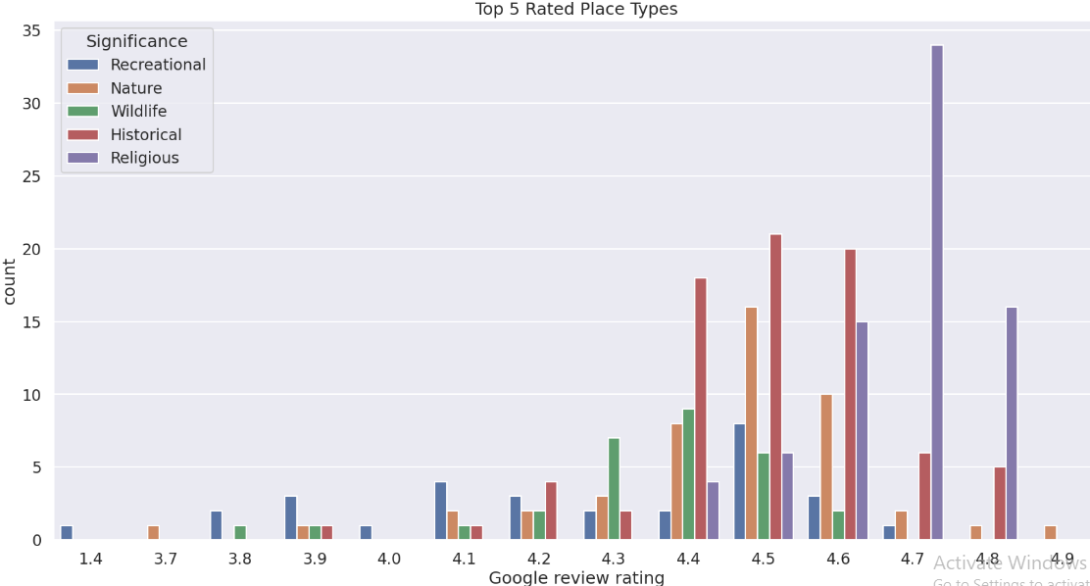

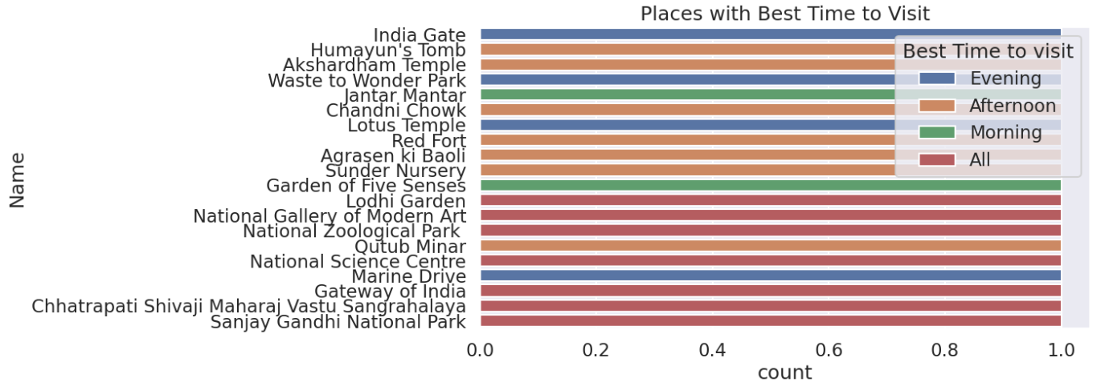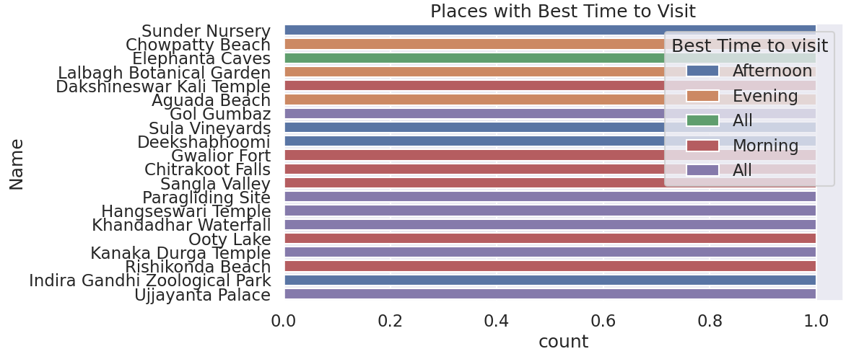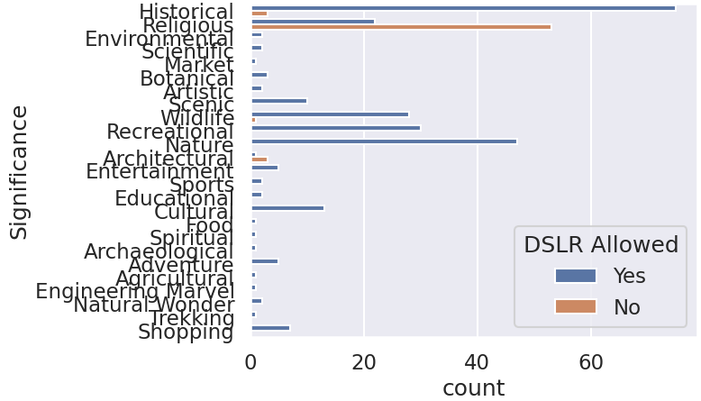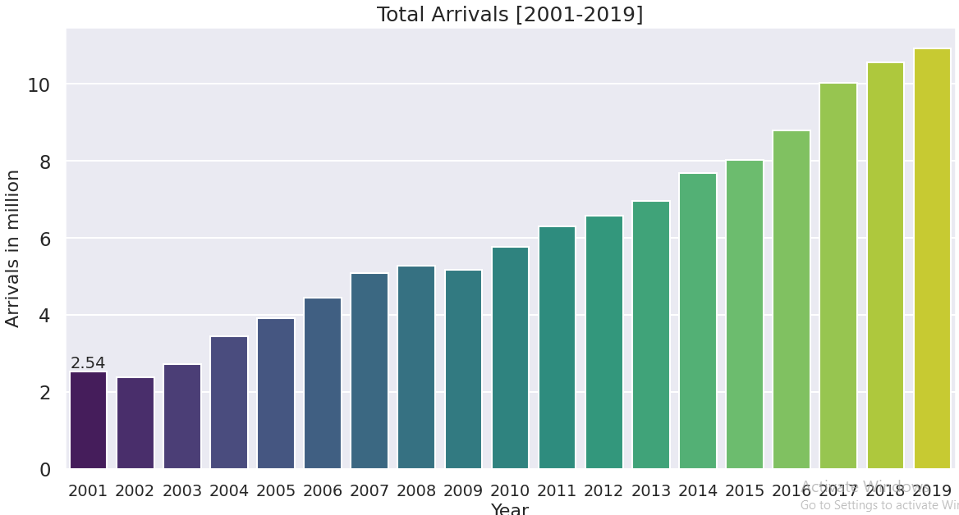

**APPENDIX-C**

**ENCLOSURES**

**1. Journal publication/Conference Paper Presented Certificates of all students.**

**2. Include certificate(s) of any Achievement/Award won in any project-related event.**

**3. Similarity Index / Plagiarism Check report clearly showing the Percentage (%). No need for a page-wise explanation.**

**4.** **Details of mapping the project with the Sustainable Development Goals (SDGs).**